**Create a sample dataset and implement the below Pig commands on the same dataset.**

1. **concat**

The concat () function of pig latin is used to concatenate two or more expressions of same type

Assume that we have a file named student_details.txt with fields like

**001,Rajiv,Reddy,21,9875627192,Hyderabad,89**

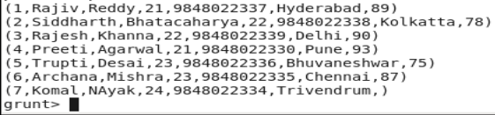

**Syntax:**

Student_name_concat = foreach student_deatils Generate CONCAT (firstname,lastname);

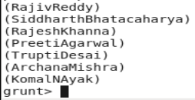

1. **Tokenize**

Tokenize function can be used to split a string. For example, let us split the above student_details.txt using the following command.



**Syntax:**

**student_name_tokenize = foreach student_details Generate TOKENIZE(firstname);**

**dump student_name_tokenize**

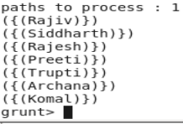

1. **Sum**

We have a file name employee.txt under /home/acadgild/pig. Running dump on employee.txt will give the following output

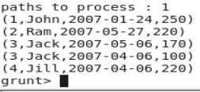

**Load Syntax:**

employee_data = LOAD '/home/acadgild/pig/employee.txt' USING PigStorage(',') as (id:int, name:chararray, workdate:chararray, daily_typing_pages:int);

**Group Syntax:**

employee_group = Group employee_data all;

**Sum Syntax:**

student_workpages_sum = foreach employee_group Generate (employee_data.name,employee_data.daily_typing_pages),SUM(employee_data.daily_typing_pages);

C:\Users\p.muthurajaiah\AppData\Local\Microsoft\Windows\INetCache\Content.Word\sum.png

1. **Min**

The min function of pig Latin is used to get the minimum value for a certain column in a single column bag. When calculating the min value NULL is ignored.

Student Details dataset:



**Min() Syntax:**

**student_group_all = Group student_details All;**

**student_gpa_min = foreach student_group_all Generate**

**(student_details.firstname, student_details.gpa), MIN(student_details.gpa);**

C:\Users\p.muthurajaiah\AppData\Local\Microsoft\Windows\INetCache\Content.Word\min.png

**5. Max**

The max function of pig Latin is used to get the maximum value for a certain column in a single column bag. When calculating the max value NULL is ignored.

Student Details dataset:



**Max() Syntax:**

**student_group_all = Group student_details All;**

**student_gpa_max = foreach student_group_all Generate**

**(student_details.firstname, student_details.gpa), MAX(student_details.gpa);**

C:\Users\p.muthurajaiah\AppData\Local\Microsoft\Windows\INetCache\Content.Word\max.png

**6. Limit**

The limit operator is used to get a limited number of tuples from a relation.

**Syntax:**

Result = LIMIT Relation_name required number of tuples;

Student Details dataset:



C:\Users\p.muthurajaiah\AppData\Local\Microsoft\Windows\INetCache\Content.Word\Limit.png

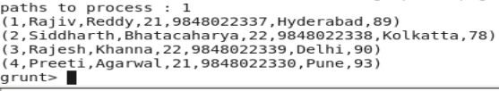

**7. Store**

We can store the loaded data in the file system using the store operator.

Given below is the syntax of store operator

STORE Relation_name INTO ‘required directory path’ [using function];

Student_details.txt dataset



STORE student_details INTO ' /home/acadgild/new_file ' USING PigStorage (',');

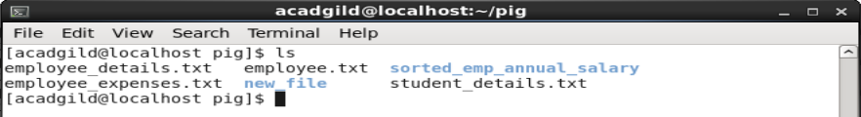

**8. Distinct**

The distinct operator is used to remove redundant information (duplicate) tuples from a relation.

**Syntax:**

Relation_name2 = DISTINCT Relatin_name1;

We have a file named student_details



C:\Users\p.muthurajaiah\AppData\Local\Microsoft\Windows\INetCache\Content.Word\distinct.png

**Since there are no duplicate entries in the relation all the rows/entries are displayed.**



**9. Flatten**

The FLATTEN operator looks like a UDF syntactically, but it is an operator that changes the structure of tuples and bags in a way that a UDF cannot. Flatten un-nests tuples as well as bags. The idea is the same, but the operation and result is different for each type of structure

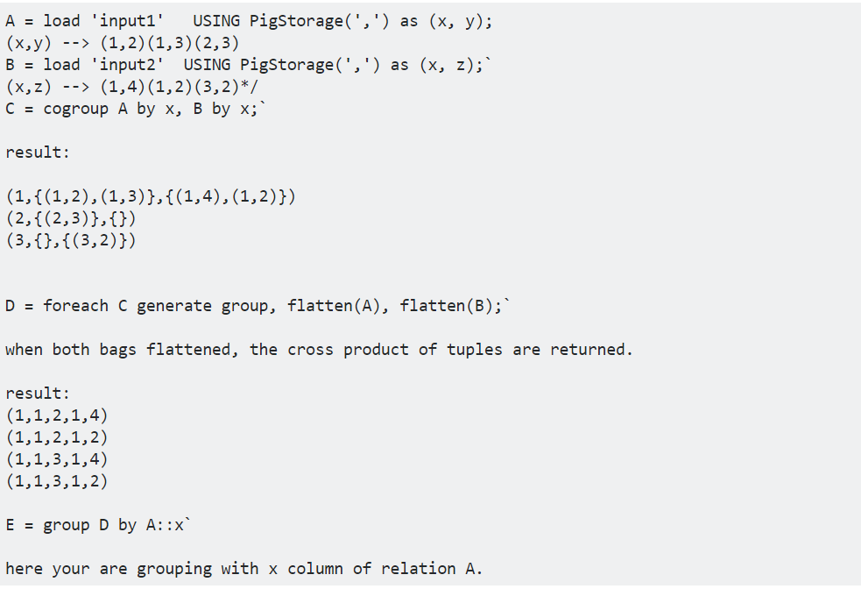

**10. IsEmpty**

The IsEmpty() function of pig latin is used to check if a bag or map is empty.

**Syntax:**

IsEmpty(Expression)

Emp_sales.txt

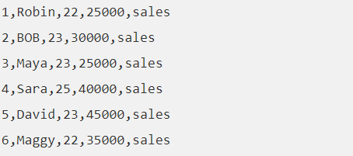

Emp_bonus.txt

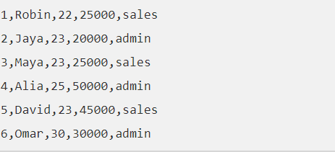

**cogroup_data = COGROUP emp_sales by age, emp_bonus by age;**

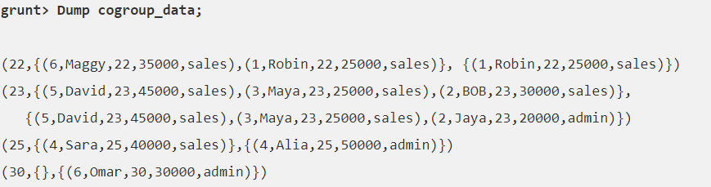

**grunt> isempty_data = filter cogroup_data by IsEmpty(emp_sales);**

